# Dijsktra’s Algorithm

## Introduction

Dijkstra’s algorithm is very similar to Prim’s algorithm for a minimum spanning tree. Like Prim’s MST, we generate a SPT (shortest path tree) with a given source as root. We maintain two sets, one set contains vertices included in the shortest path tree, the other set includes vertices not yet included in the shortest path tree. At every step of the algorithm, we find a vertex which is in the other set (set of not yet included) and has a minimum distance from the source.

Below are the detailed steps used in Dijkstra’s algorithm to find the shortest path from a single source vertex to all other vertices in the given graph.

## Algorithm

1. Create a set sptSet (shortest path tree set) that keeps track of vertices included in the shortest path tree, whose minimum distance from source is calculated and finalized. Initially, this set is empty.
2. Assign a distance value to all vertices in the input graph. Initialize all distance values as INFINITE. Assign distance value as 0 for the source vertex so that it is picked first.
3. While sptSet doesn’t include all vertices.
4. Pick a vertex u which is not there in sptSet and has minimum distance value.
5. Include u to sptSet.
6. Update the distance value of all adjacent vertices of u. To update the distance values, iterate through all adjacent vertices. For every adjacent vertex v, if the sum of distance value of u (from source) and weight of edge u-v, is less than the distance value of v, then update the distance value of v.

## Code

import sys

from terminaltables import SingleTable

from common import clear

class Graph():

def __init__(self, vertices):

self.V = vertices

self.graph = [[0 for column in range(vertices)]

for row in range(vertices)]

def printFinalDistances(self,src, dist):

clear()

self.printGraph()

sourceInfo = ["Source"], [src]

sourceTable = SingleTable(sourceInfo)

print(sourceTable.table)

data = ["Vertex"]+list(range(self.V)), ["Distance from source"]+dist

table = SingleTable(data)

print(table.table)

def printGraph(self):

table = SingleTable(self.graph)

table.inner_row_border = True

print(table.table)

def findMinimumDistance(self, dist, sptSet):

min = sys.maxsize

for v in range(self.V):

if dist[v] < min and sptSet[v] == False:

min = dist[v]

min_index = v

return min_index

def dijkstra(self, src):

dist = [sys.maxsize] * self.V

dist[src] = 0

sptSet = [False] * self.V

for cout in range(self.V):

u = self.findMinimumDistance(dist, sptSet)

sptSet[u] = True

for v in range(self.V):

if self.graph[u][v] > 0 and sptSet[v] == False and dist[v] > dist[u] + self.graph[u][v]:

dist[v] = dist[u] + self.graph[u][v]

self.printFinalDistances(src,dist)

g = Graph(9)

g.graph = [

[0, 4, 0, 0, 0, 0, 0, 8, 0],

[4, 0, 8, 0, 0, 0, 0, 11, 0],

[0, 8, 0, 7, 0, 4, 0, 0, 2],

[0, 0, 7, 0, 9, 14, 0, 0, 0],

[0, 0, 0, 9, 0, 10, 0, 0, 0],

[0, 0, 4, 14, 10, 0, 2, 0, 0],

[0, 0, 0, 0, 0, 2, 0, 1, 6],

[8, 11, 0, 0, 0, 0, 1, 0, 7],

[0, 0, 2, 0, 0, 0, 6, 7, 0]

]

g.dijkstra(int(input("Enter the source node: ")))

## Result

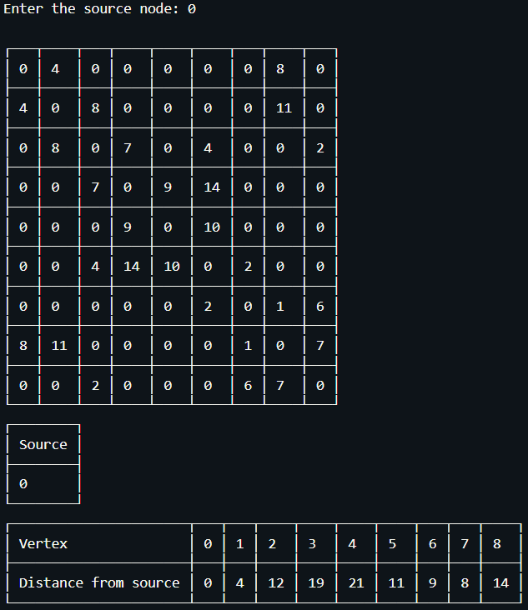

# Prim’s Algorithm

## Introduction

Like Kruskal’s algorithm, Prim’s algorithm is also a Greedy algorithm. It starts with an empty spanning tree. The idea is to maintain two sets of vertices. The first set contains the vertices already included in the MST, the other set contains the vertices not yet included. At every step, it considers all the edges that connect the two sets, and picks the minimum weight edge from these edges. After picking the edge, it moves the other endpoint of the edge to the set containing MST.

A group of edges that connects two sets of vertices in a graph is called cut in graph theory. So, at every step of Prim’s algorithm, we find a cut (of two sets, one contains the vertices already included in MST and other contains rest of the vertices), pick the minimum weight edge from the cut and include this vertex to MST Set (the set that contains already included vertices).

## Algorithm

1. Create a set mstSet that keeps track of vertices already included in MST.
2. Assign a key value to all vertices in the input graph. Initialize all key values as INFINITE. Assign the key value as 0 for the first vertex so that it is picked first.
3. While mstSet doesn’t include all vertices.
4. Pick a vertex u which is not there in mstSet and has minimum key value.
5. Include u to mstSet.
6. Update key value of all adjacent vertices of u. To update the key values, iterate through all adjacent vertices. For every adjacent vertex v, if weight of edge u-v is less than the previous key value of v, update the key value as weight of u-v

The idea of using key values is to pick the minimum weight edge from the cut. The key values are used only for vertices which are not yet included in MST, the key value for these vertices indicate the minimum weight edges connecting them to the set of vertices included in MST.

## Code

import sys # Library for INT_MAX

from common import clear, custom_print

from terminaltables import SingleTable

class Graph():

def __init__(self, vertices):

self.V = vertices

self.graph = [[0 for column in range(vertices)]

for row in range(vertices)]

def printMST(self, parent):

clear()

self.printGraph()

data = [["Start Edge", "End Edge", "Weight"]] + [[parent[i],

i, self.graph[i][parent[i]]] for i in range(1, self.V)]

table = SingleTable(data)

table.inner_row_border = True

print(table.table)

def printFinalDistances(self, src, dist):

clear()

self.printGraph()

sourceInfo = ["Source"], [src]

sourceTable = SingleTable(sourceInfo)

print(sourceTable.table)

data = ["Vertex"]+list(range(self.V)), ["Distance from source"]+dist

table = SingleTable(data)

print(table.table)

def printGraph(self):

table = SingleTable(self.graph)

table.inner_row_border = True

print(table.table)

def minKey(self, key, mstSet):

min = sys.maxsize

for v in range(self.V):

if key[v] < min and mstSet[v] == False:

min = key[v]

min_index = v

return min_index

def primMST(self, src):

key = [sys.maxsize] * self.V

parent = [None] * self.V

key[0] = src

mstSet = [False] * self.V

parent[0] = -1

for cout in range(self.V):

u = self.minKey(key, mstSet)

mstSet[u] = True

for v in range(self.V):

if self.graph[u][v] > 0 and mstSet[v] == False and key[v] > self.graph[u][v]:

key[v] = self.graph[u][v]

parent[v] = u

self.printMST(parent)

g = Graph(5)

g.graph = [[0, 2, 0, 6, 0],

[2, 0, 3, 8, 5],

[0, 3, 0, 0, 7],

[6, 8, 0, 0, 9],

[0, 5, 7, 9, 0]]

g.primMST(2)

## Result

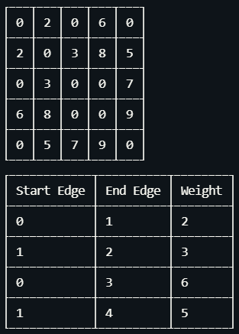

## 

# Kruskal’s Algorithm

## Introduction

This algorithm is a Greedy Algorithm. The Greedy Choice is to pick the smallest weight edge that does not cause a cycle in the MST constructed so far. Given a connected and undirected graph, a spanning tree of that graph is a subgraph that is a tree and connects all the vertices together. A single graph can have many different spanning trees. A minimum spanning tree (MST) or minimum weight spanning tree for a weighted, connected, undirected graph is a spanning tree with a weight less than or equal to the weight of every other spanning tree. The weight of a spanning tree is the sum of weights given to each edge of the spanning tree.

A minimum spanning tree has (V – 1) edges where V is the number of vertices in the given graph.

## Algorithm

1. Sort all the edges in non-decreasing order of their weight.
2. Pick the smallest edge. Check if it forms a cycle with the spanning tree formed so far. If the cycle is not formed, include this edge. Else, discard it.
3. Repeat step#2 until there are (V-1) edges in the spanning tree.

## Code

from terminaltables import SingleTable

from common import clear

class Graph:

def __init__(self, vertices):

self.V = vertices

self.graph = []

def addEdge(self, u, v, w):

self.graph.append([u, v, w])

def find(self, parent, i):

if parent[i] == i:

return i

return self.find(parent, parent[i])

def union(self, parent, rank, x, y):

xroot = self.find(parent, x)

yroot = self.find(parent, y)

if rank[xroot] < rank[yroot]:

parent[xroot] = yroot

elif rank[xroot] > rank[yroot]:

parent[yroot] = xroot

else:

parent[yroot] = xroot

rank[xroot] += 1

def KruskalMST(self):

result = []

i = 0

e = 0

self.graph = sorted(self.graph,

key=lambda item: item[2])

parent = []

rank = []

for node in range(self.V):

parent.append(node)

rank.append(0)

while e < self.V - 1:

u, v, w = self.graph[i]

i = i + 1

x = self.find(parent, u)

y = self.find(parent, v)

if x != y:

e = e + 1

result.append([u, v, w])

self.union(parent, rank, x, y)

# Else discard the edge

minimumCost = 0

clear()

print("Edges in the constructed MST")

data = [["Edge 1", "Edge 2", "Weight"]]

for u, v, weight in result:

minimumCost += weight

data.append([u, v, weight])

table = SingleTable(data)

table.inner_row_border = True

print(table.table)

print(SingleTable([["Minimum Spanning Tree", minimumCost]]).table)

clear()

number_of_nodes = int(input("Enter the number of nodes: "))

number_of_edges = int(input("Enter the number of edges: "))

g = Graph(number_of_nodes)

for edge in range(number_of_edges):

clear()

g.addEdge(int(input("Enter from edge: ")), int(

input("Enter to edge: ")), int(input("Enter edge weight: ")))

g = Graph(4)

g.addEdge(0, 1, 4)

g.addEdge(0, 2, 6)

g.addEdge(0, 3, 5)

g.addEdge(1, 3, 15)

g.addEdge(2, 3, 4)

g.KruskalMST()

## Result

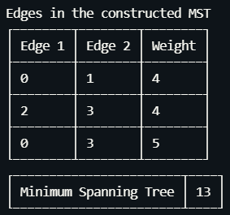

## 

# 

# Bellman Ford Algorithm

## Introduction

Given a graph and a source vertex src in the graph, find shortest paths from src to all vertices in the given graph. The graph may contain negative weight edges. Dijkstra doesn’t work for Graphs with negative weight edges, Bellman-Ford works for such graphs.

Bellman-Ford is also simpler than Dijkstra and suits well for distributed systems. But the time complexity of Bellman-Ford is O(VE), which is more than Dijkstra.

## Algorithm

**Input**: Graph and a source vertex src

**Output**: Shortest distance to all vertices from src. If there is a negative weight cycle, then shortest distances are not calculated, negative weight cycle is reported.

1. This step initializes distances from the source to all vertices as infinite and distance to the source itself as 0. Create an array dist[] of size |V| with all values as infinite except dist[src] where src is source vertex.
2. This step calculates shortest distances. Do following |V|-1 times where |V| is the number of vertices in a given graph.   
   Do following for each edge u-v   
    If dist[v] > dist[u] + weight of edge uv, then update dist[v]  
    dist[v] = dist[u] + weight of edge uv
3. This step reports if there is a negative weight cycle in the graph.  
   Do following for each edge u-v   
    If dist[v] > dist[u] + weight of edge uv, then “Graph contains negative weight cycle”

The idea of step 3 is, step 2 guarantees the shortest distances if the graph doesn’t contain a negative weight cycle. If we iterate through all edges one more time and get a shorter path for any vertex, then there is a negative weight cycle

## Code

from terminaltables import SingleTable

from common import clear

class Graph:

def __init__(self, vertices):

self.V = vertices # No. of vertices

self.graph = []

# function to add an edge to graph

def addEdge(self, u, v, w):

self.graph.append([u, v, w])

# utility function used to print the solution

def printArr(self,src, dist):

clear()

sourceInfo = ["Source"], [src]

sourceTable = SingleTable(sourceInfo)

print(sourceTable.table)

data = ["Vertex"]+list(range(self.V)), ["Distance from source"]+dist

table = SingleTable(data)

print(table.table)

def BellmanFord(self, src):

dist = [float("Inf")] * self.V

dist[src] = 0

for _ in range(self.V - 1):

for u, v, w in self.graph:

if dist[u] != float("Inf") and dist[u] + w < dist[v]:

dist[v] = dist[u] + w

for u, v, w in self.graph:

if dist[u] != float("Inf") and dist[u] + w < dist[v]:

print("Graph contains negative weight cycle")

return

self.printArr(src,dist)

g = Graph(4)

g.addEdge(0,1,4)

g.addEdge(0,3,5)

g.addEdge(1,3,4)

g.addEdge(3,2,3)

g.addEdge(2,1,-5)

g.BellmanFord(int(input("Enter the source node: ")))

## Result

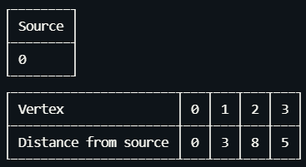

# 

# 

# CRC - Cyclic Redundancy Check

## Introduction

A cyclic redundancy check (CRC) is an error-detecting code commonly used in digital networks and storage devices to detect accidental changes to raw data. Blocks of data entering these systems get a short check value attached, based on the remainder of a polynomial division of their contents. On retrieval, the calculation is repeated and, in the event the check values do not match, corrective action can be taken against data corruption. CRCs can be used for error detection and correction.

CRC uses Generator Polynomial which is available on both sender and receiver sides. An example generator polynomial is of the form like $x^{3}+1.$ This generator polynomial represents key **1001**. Another example is $x^{2}+ x$ that represents key **110**.

## Algorithm

### Sender Side

1. The task is to send a string data to the receiver side.
2. The sender sends a string.
3. First, this string is converted to a binary string “100010110101101001110”.   
   The key is known to both the side sender and receiver.
4. This data is encoded using the CRC code using the key in the sender side.
5. This encoded data is sent to the receiver.
6. Receiver later decodes the encoded data string to verify whether there was any error or not.

### Receiver Side

1. The receiver receives the encoded data string from the sender.
2. Receiver with the help of the same **key** decodes the data and finds out the remainder.
3. If the **remainder** is **zero** then it means there is **no error** in data sent by the sender to the receiver.
4. If the **remainder** comes out to be **non-zero** it means there was an **error**, a **negative acknowledgement** is sent to the sender. The sender then resends the data until the receiver receives correct data.

## Code

### Sender Side

import socket

def xor(a, b):

# initialize result

result = []

for i in range(1, len(b)):

if a[i] == b[i]:

result.append('0')

else:

result.append('1')

return ''.join(result)

def bitstring_to_bytes(s):

v = int(s, 2)

b = bytearray()

while v:

b.append(v & 0xff)

v >>= 8

return bytes(b[::-1])

# Performs Modulo-2 division

def mod2div(divident, divisor):

pick = len(divisor)

tmp = divident[0 : pick]

while pick < len(divident):

if tmp[0] == '1':

tmp = xor(divisor, tmp) + divident[pick]

else:

tmp = xor('0'*pick, tmp) + divident[pick]

pick += 1

if tmp[0] == '1':

tmp = xor(divisor, tmp)

else:

tmp = xor('0'*pick, tmp)

checkword = tmp

return checkword

def encodeData(data, key):

l_key = len(key)

# Appends n-1 zeroes at end of data

appended_data = data + '0'*(l_key-1)

remainder = mod2div(appended_data, key)

# Append remainder in the original data

codeword = data + remainder

return codeword

# Create a socket object

s = socket.socket()

# Define the IP & PORT on which you want to connect

PORT = 12345

IP = '127.0.0.1'

# connect to the server on local computer

s.connect((IP, PORT))

input_string = input("Enter data you want to send: ")

key = input("Enter the polynomial key: ")

data = (''.join(format(ord(x), 'b') for x in input_string))

print(data)

ans = encodeData(data,key)

print(ans)

s.sendall(bytes(ans, "utf-8"))

# receive data from the server

print (s.recv(1024).decode("utf-8"))

# close the connection

s.close()

### Receiver Side

import socket

def xor(a, b):

result = []

for i in range(1, len(b)):

if a[i] == b[i]:

result.append('0')

else:

result.append('1')

return ''.join(result)

# Performs Modulo-2 division

def mod2div(divident, divisor):

pick = len(divisor)

tmp = divident[0: pick]

while pick < len(divident):

if tmp[0] == '1':

tmp = xor(divisor, tmp) + divident[pick]

else:

tmp = xor('0'*pick, tmp) + divident[pick]

pick += 1

if tmp[0] == '1':

tmp = xor(divisor, tmp)

else:

tmp = xor('0'*pick, tmp)

checkword = tmp

return checkword

def decodeData(data, key):

l_key = len(key)

# Appends n-1 zeroes at end of data

appended_data = data + '0'*(l_key-1)

remainder = mod2div(appended_data, key)

return remainder

# Creating Socket

s = socket.socket()

print("Socket successfully created")

# reserve a port on your computer in our

# case it is 12345 but it can be anything

PORT = 12345

IP = "127.0.0.1"

s.bind(('', PORT))

print("socket binded to %s" % (PORT))

# put the socket into listening mode

maxConnections = 5

s.listen(maxConnections)

print("socket is listening with maximum {} connections".format(maxConnections))

key = input("Enter the polynomial key: ")

while True:

connection, address = s.accept()

print('Got connection from', address)

# Get data from client

data = connection.recv(1024)

print(data)

data = data.decode("utf-8")

print(data)

if not data:

break

ans = decodeData(data, key)

# print("Remainder after decoding is->"+ans)

# If remainder is all zeros then no error occurred

temp = "0" * (len(key) - 1)

if ans == temp:

connection.sendall(bytes("Data: " + data + " Received. No error FOUND", "utf-8"))

else:

connection.sendall(bytes("The received data is corrupted.", "utf-8"))

connection.close()

## 

## Result

### Receiver Side

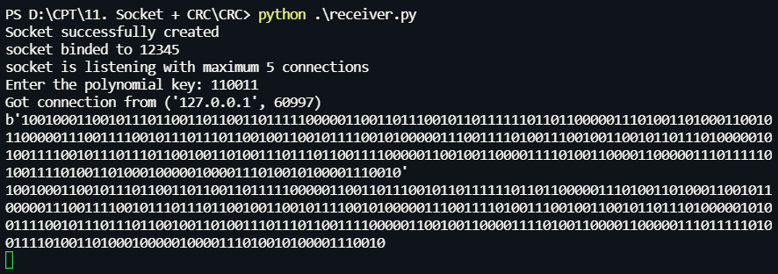

### Sender Side

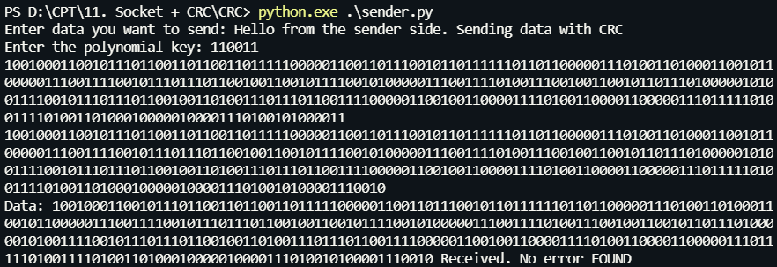

# 

# 

# Sockets

## Introduction

Socket programming is a way of connecting two nodes on a network to communicate with each other. One socket(node) listens on a particular port at an IP, while another socket reaches out to the other to form a connection. Server forms the listener socket while the client reaches out to the server.

They are the real backbones behind web browsing. In simpler terms there is a server and a client.

## Code

### Client Side

import socket

IP = "127.0.0.1"

s = socket.socket()

s.connect((IP, 9945))

received = ''

while True:

msg = s.recv(4096)

if (len(msg) <= 0):

break

received += msg.decode("utf-8")

print(received)

### Server Side

import socket

IP = "127.0.0.1"

s = socket.socket()

s.bind((IP, 9945))

print("IP address of the server is {}".format(IP))

s.listen()

message = input("Enter the message to send to the receiver: ")

while True:

connection, clientAddress = s.accept()

print(f"Connection to {clientAddress} establised")

connection.send(bytes(message, "utf-8"))

connection.close()

## Result

### Server Side

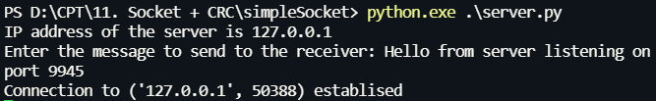

### Client Side



## 

## 

**Bit Stuffing**

Data link layer is responsible for something called Framing, which is the division of stream of bits from network layer into manageable units (called frames). Frames could be of fixed size or variable size. In variable-size framing, we need a way to define the end of the frame and the beginning of the next frame.

**Bit stuffing** is the insertion of non information bits into data. Note that stuffed bits should not be confused with overhead bits. **Overhead bits** are non-data bits that are necessary for transmission (usually as part of headers, checksums etc.).

**Applications of Bit Stuffing –**

1. synchronize several channels before multiplexing
2. rate-match two single channels to each other
3. run length limited coding

**Run length limited coding –** To limit the number of consecutive bits of the same value(i.e., binary value) in the data to be transmitted. A bit of the opposite value is inserted after the maximum allowed number of consecutive bits.

Bit stuffing technique does not ensure that the sent data is intact at the receiver side (i.e., not corrupted by transmission errors). It is merely a way to ensure that the transmission starts and ends at the correct places.

**Disadvantages of Bit Stuffing –**  
The code rate is unpredictable; it depends on the data being transmitted.

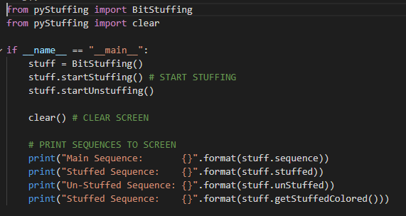

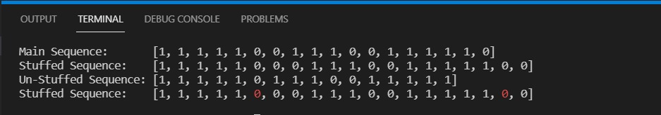

**Byte Stuffing**

A byte (usually escape character(ESC)), which has a predefined bit pattern is added to the data section of the frame when there is a character with the same pattern as the flag. Whenever the receiver encounters the ESC character, it removes from the data section and treats the next character as data, not a flag.

But the problem arises when the text contains one or more escape characters followed by a flag. To solve this problem, the escape characters that are part of the text are marked by another escape character i.e., if the escape character is part of the text, an extra one is added to show that the second one is part of the text.

